
Studio Woquini di Lucio Bigi
• Via Luciano Dodi, 9 • 42015 Correggio (RE) • www.woquini.it • tel. e fax 0522 64.18.67 •
• e-mail: studio@woquini.it • P.IVA 01924880352 •
Professionista di cui alla legge 4/2013

Correggio, 31 luglio 2017

Griglia WATER

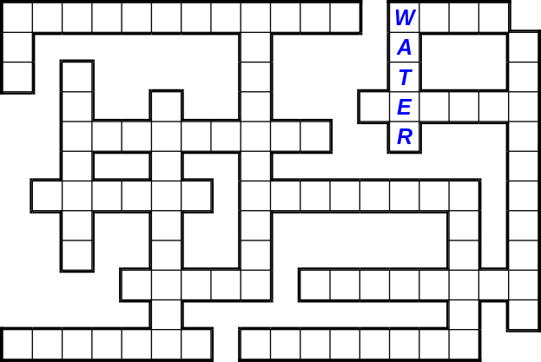 | 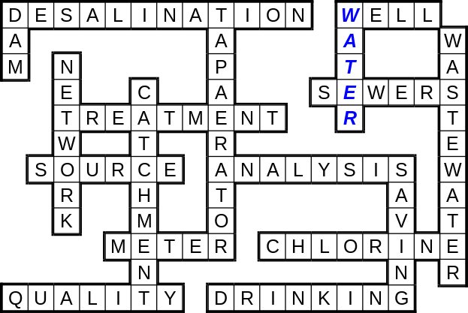

Analysis Catchment Chlorine Dam Desalination Drinking leakage Meter Network Quality Saving Sewers Source Tap-aerator Treatment Wastewater Water Well

Soluzione: LEAKAGE

Griglia ENERGY

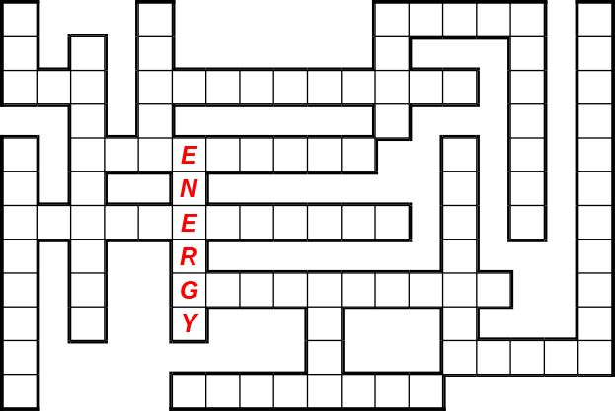 | 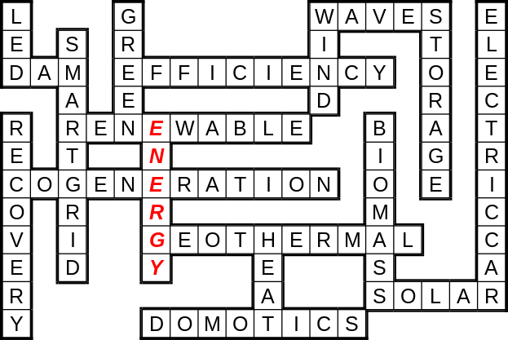

Biomass coal Co-generation Dam Domotics Efficiency Electric-car Energy Geothermal Green Heat Led Recovery Renewable Smart-grid Solar Storage Waves Wind

Soluzione: COAL

Griglia WASTE

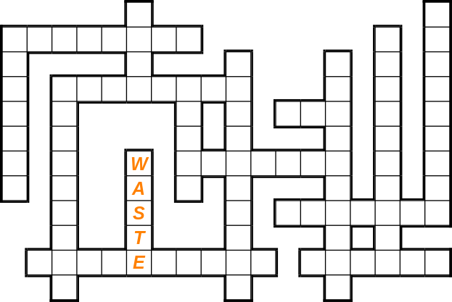 | 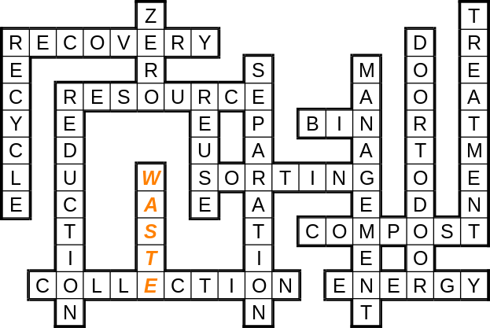

Bin Collection Compost Door-to-door Energy littering Management Recovery Recycle Reduction Resource Reuse Separation Sorting Treatment Waste Zero

Soluzione: LITTERING

